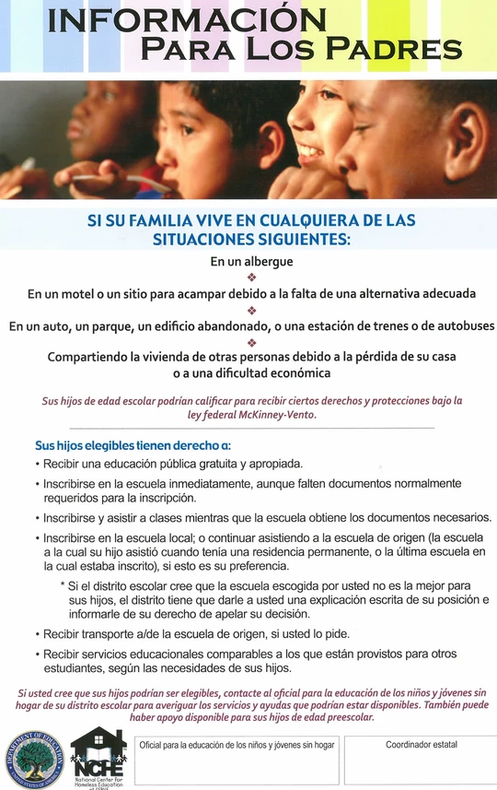

Cheryl Kosmatha at 573-522-8763

Kristy Forrester at 660-837-3400