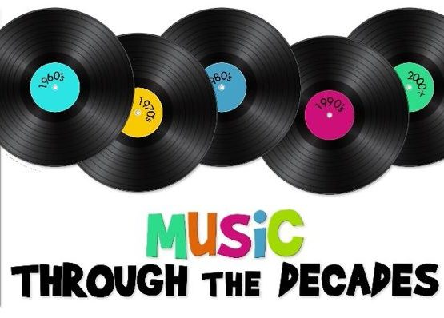
We are VERY excited to invite you to Spring Concert on Tuesday, April 27th beginning at 7 pm. Be prepared to sing along with all the golden oldies!

Since we missed out on the winter program due to COVID restrictions, the students and I are excited to show-off their musical talent.

Preschoolers and Kindergartners will recreate songs from the 1930’s

First – Fourth graders will perform songs from the 1940’s & 1950’s

Fifth & Sixth graders will delight us with songs from the 70’s & 80’s

Seventh & Eighth graders will entertain with songs from the 1990’s to now

Students need to be in their homerooms by 6:45 pm in order to get lined up and ready for the show.

Students are welcome to dress in any of the time periods being performed from the 30’s to the present. For example, even though Kindergartners are singing songs from the 30’s, they can still dress like someone from the 80’s.

It is not required to dress up and parents are not expected to purchase special costumes or clothing. Nice dress outfits are fine.

We look forward to seeing everyone on this night of entertainment.
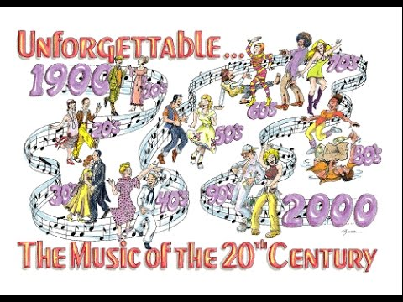

Mrs. Fletcher

